Open eclipse

Select File -> new-> project

Then give any project name then press Finish button

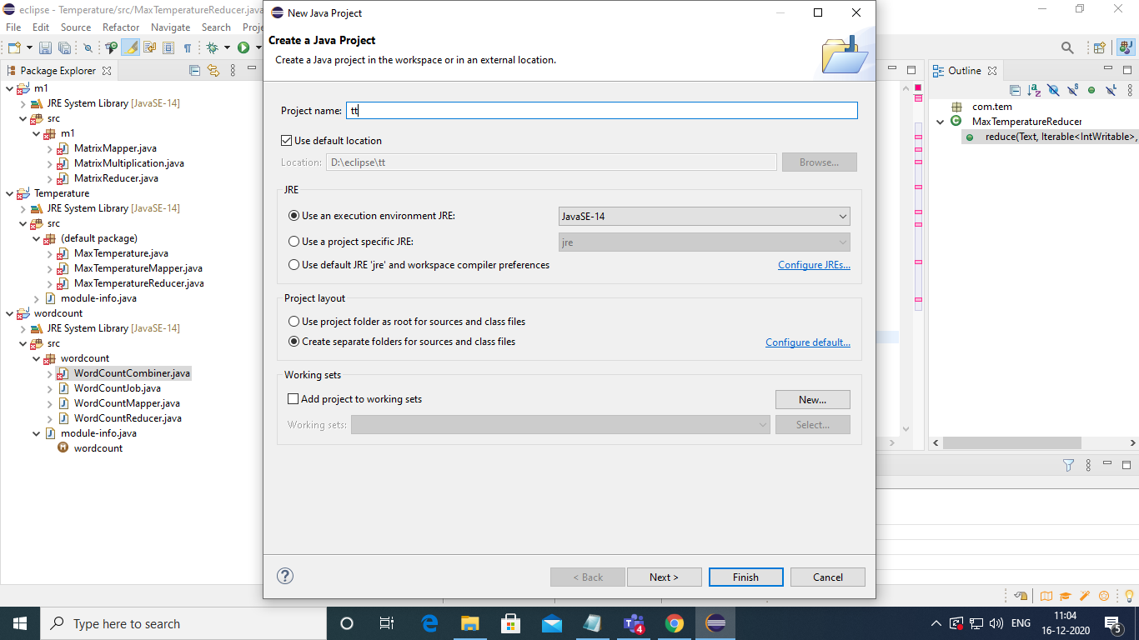

Write source code for this project

create classes under this project by select project name(left side of the window) right click new-> class

3 classes need to create 1.mapper, 2. Reducer, 3. Driver

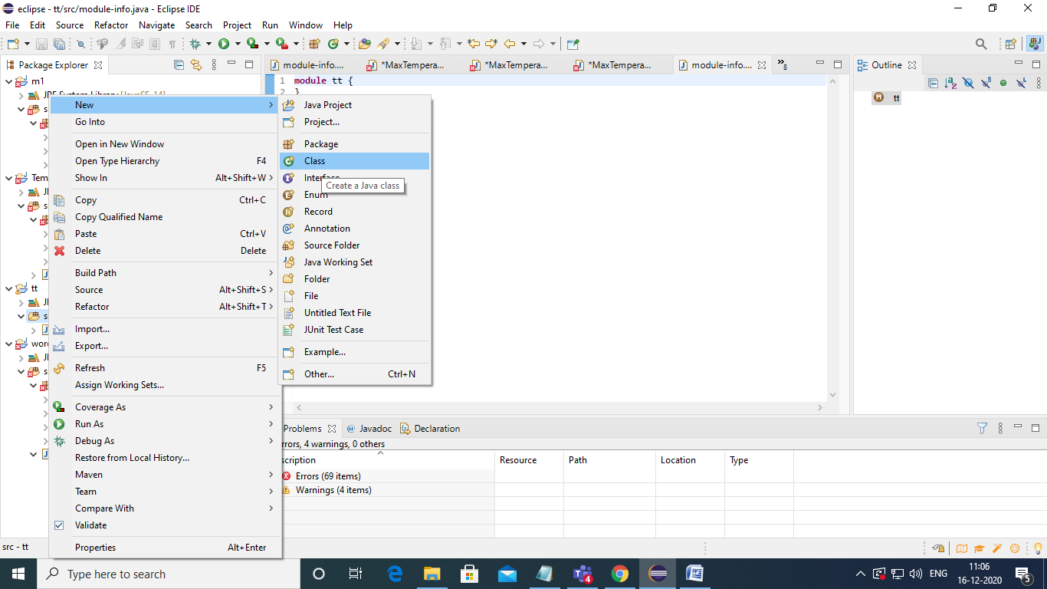

Give the name of the class in your code then finish

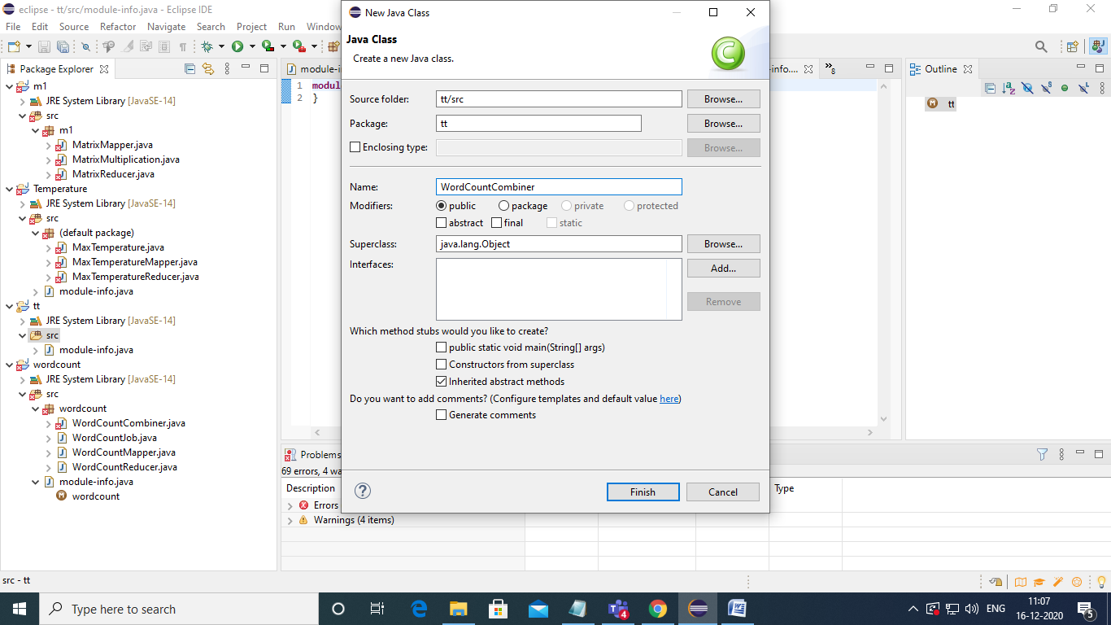

Copy the code related to that class

Next need to specify external jar files so, download two external jar files

1. Hadoop common jar
2. Hadoop mapreduce client core jar files

Then extract these two jar files

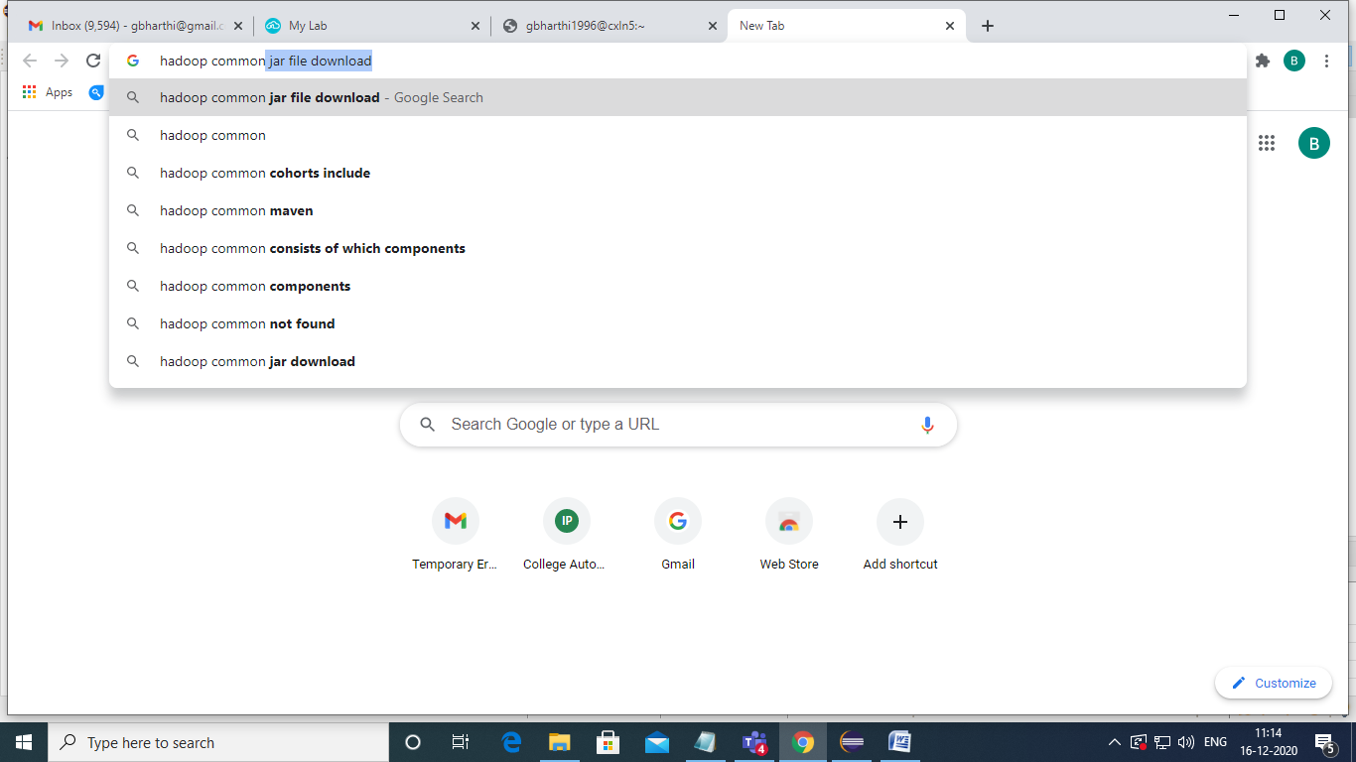



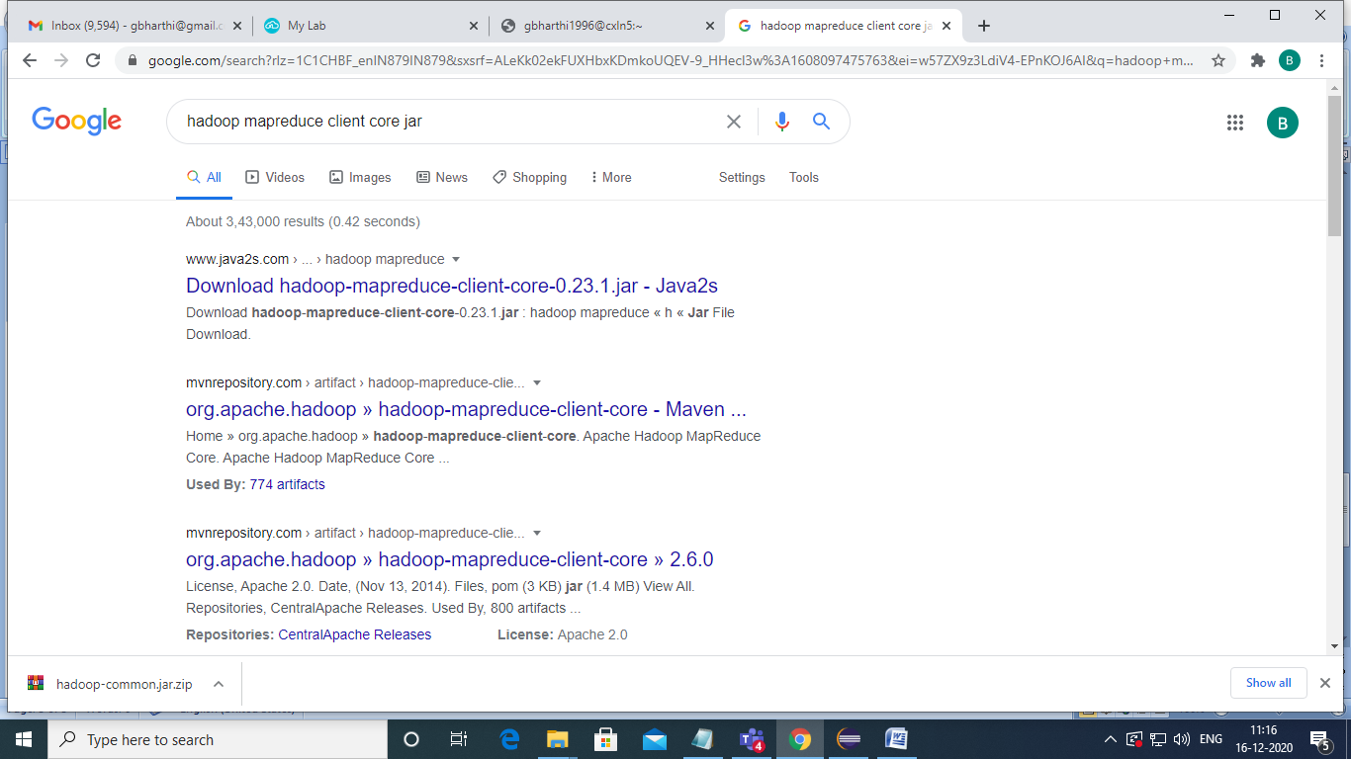

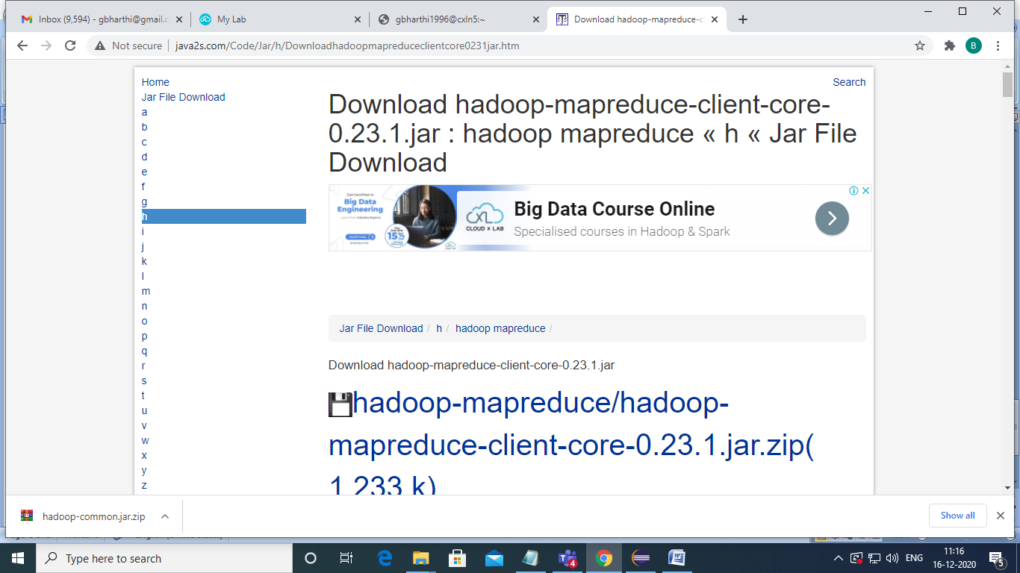

After extracting jar files add these two jar files to your project by

Right click on project name here wordcount-> Build path-> Add external archives

Then select hadoop common jar file

Again Right click on project name here wordcount-> Build path-> Add external archives

Then select mapreduce client core jar file

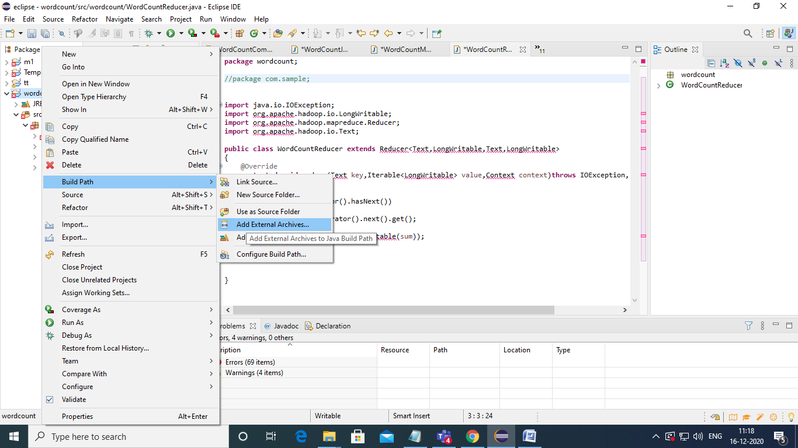

Selection of jar file

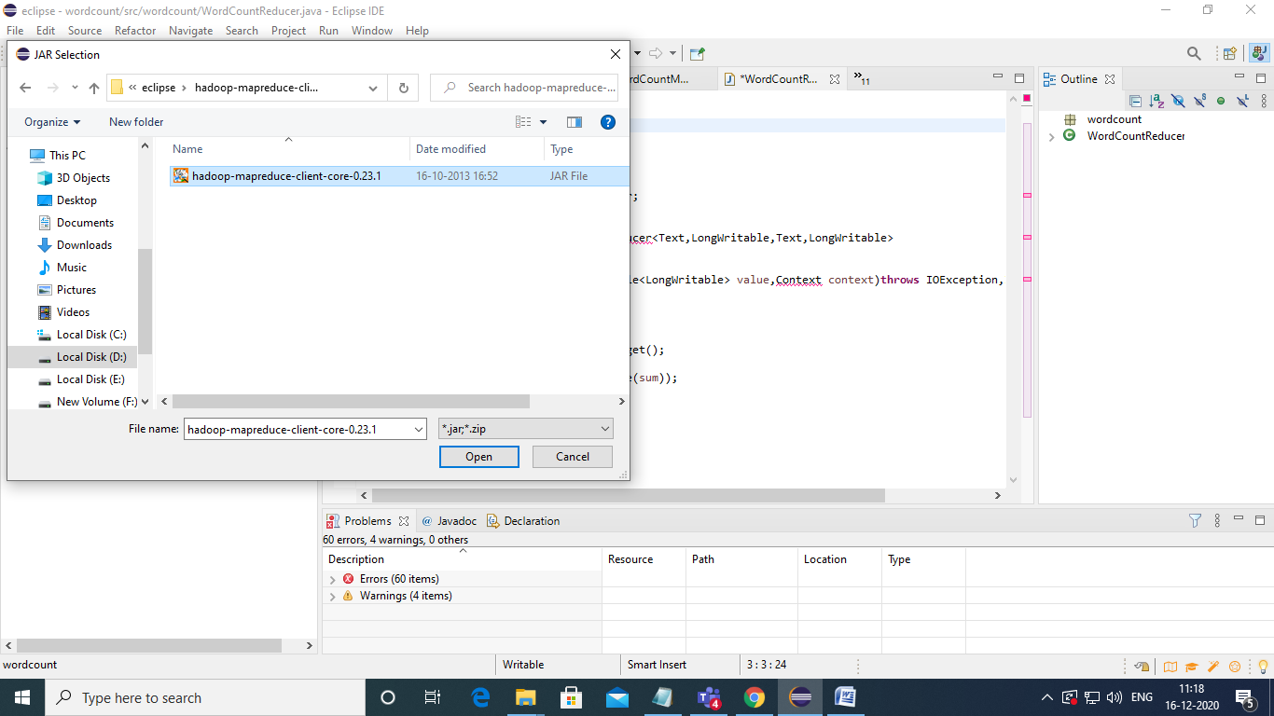

Now creation of jar file

Select project (wordcount) rightclick -> Export

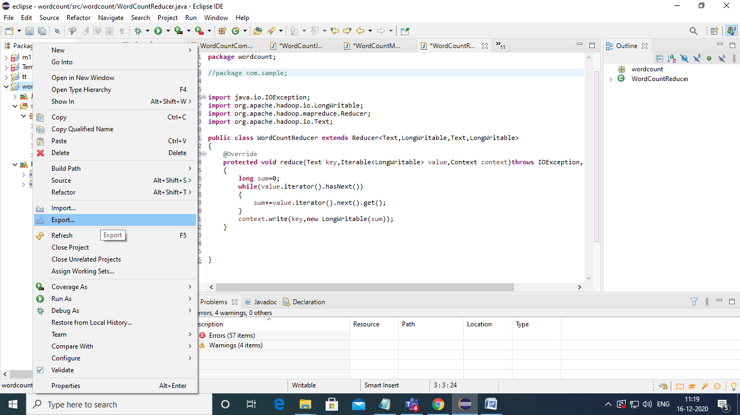

Then select java->JAR file click next

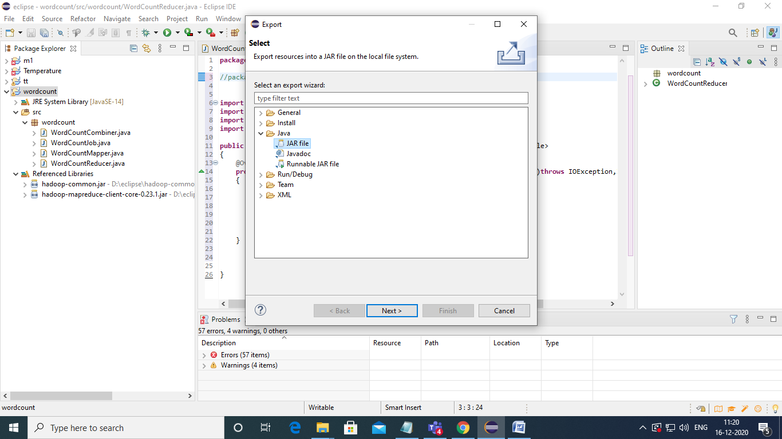

Select wordcount by click on that then give the name of the jar file then press next button

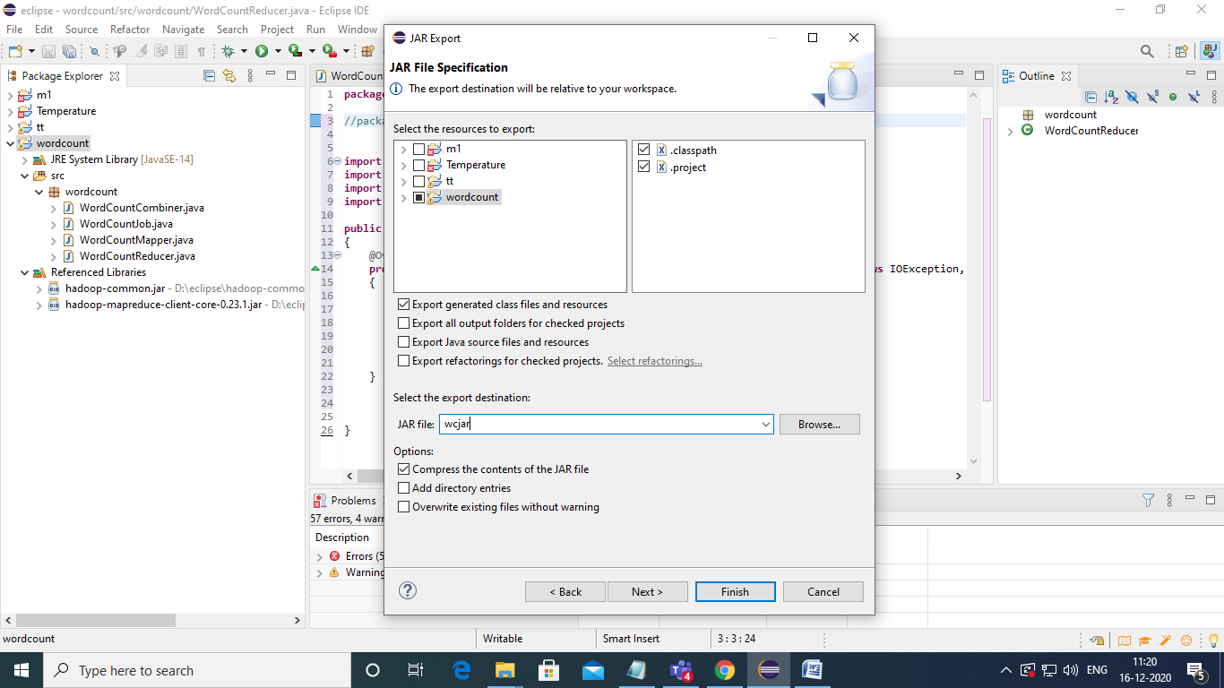

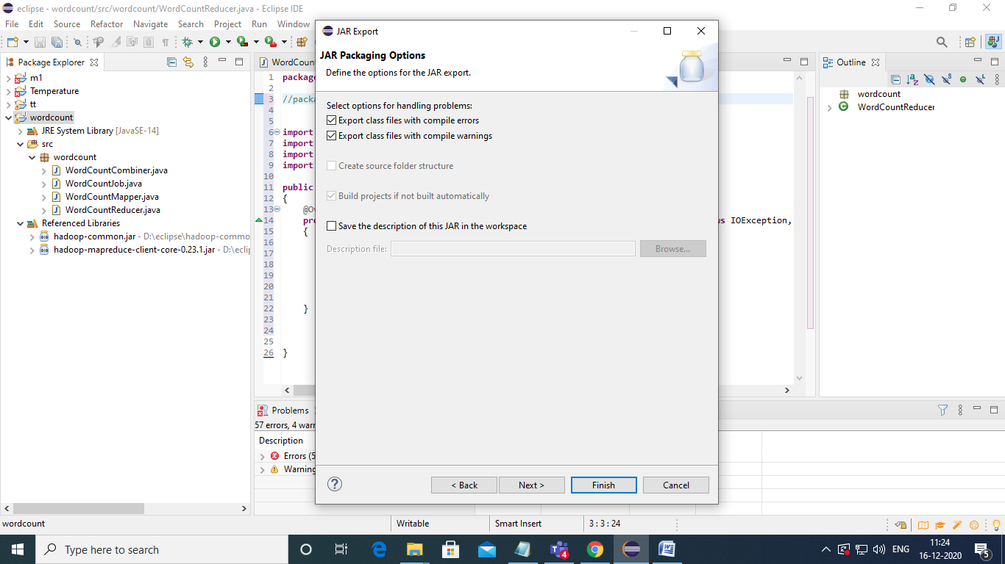

Press next

Then give main class name here (i.e driver class name)

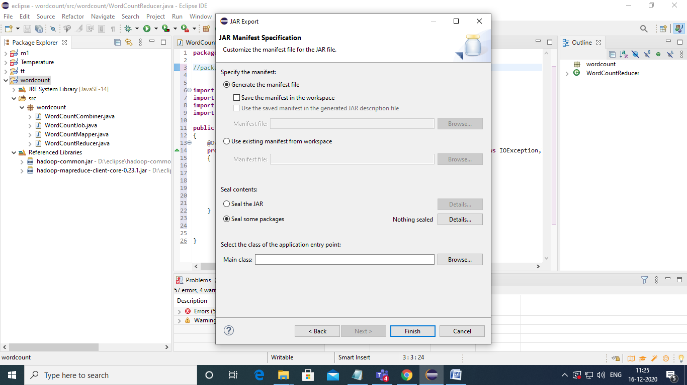

Browse main class name

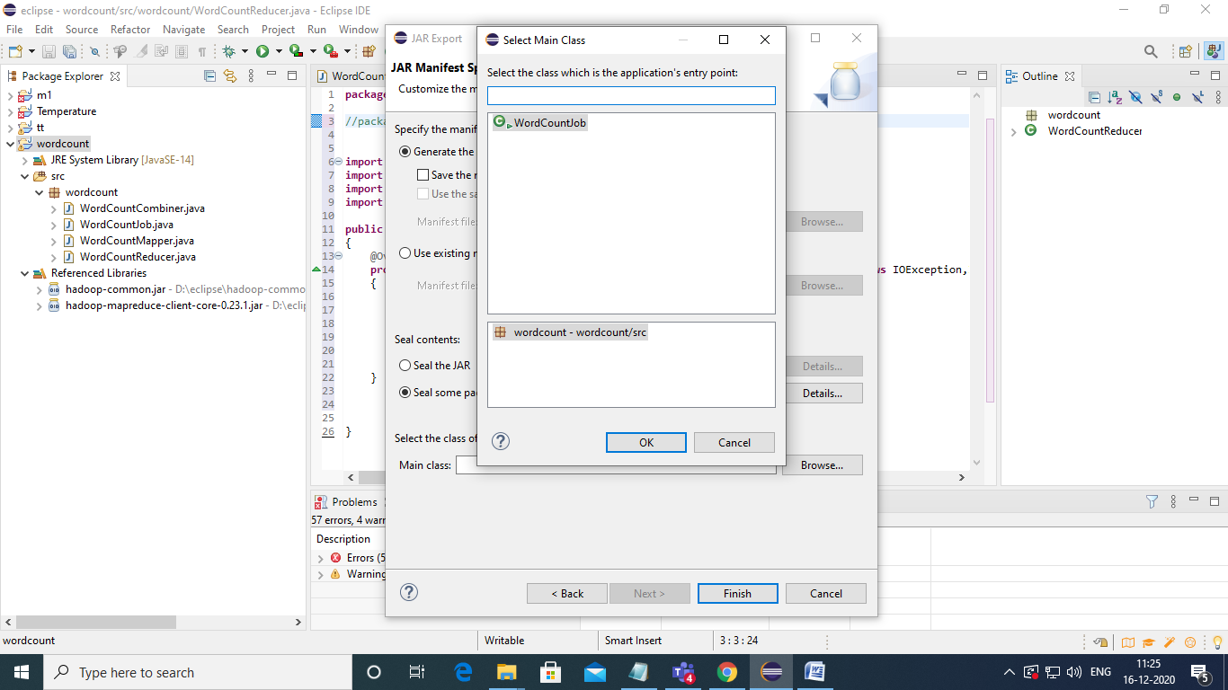

**After selecting main class name press ok**

**Press finish tab**

**Next upload jar file and data file to cloud for this download winscp for transferring files from our localdisk to cloudx**

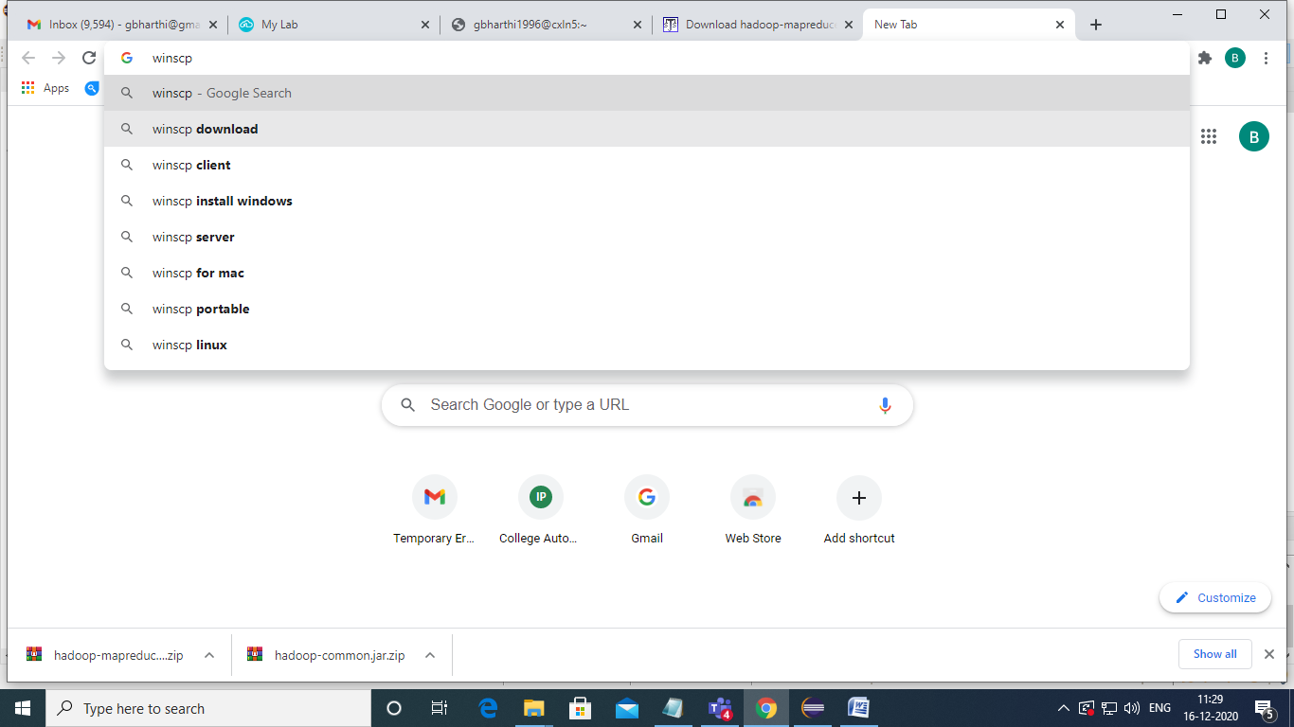

**Down load winscp**



Install it

Open winscp

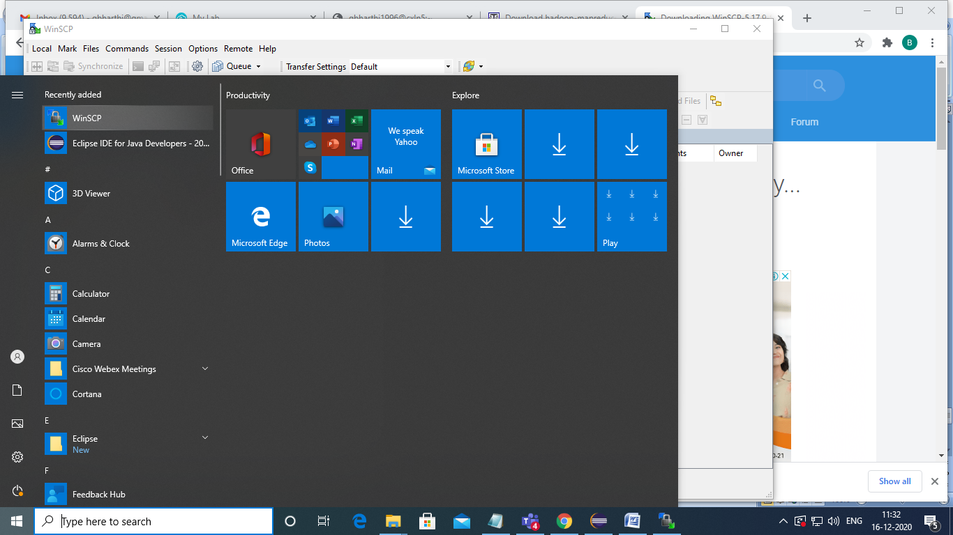

For uploading files create one session

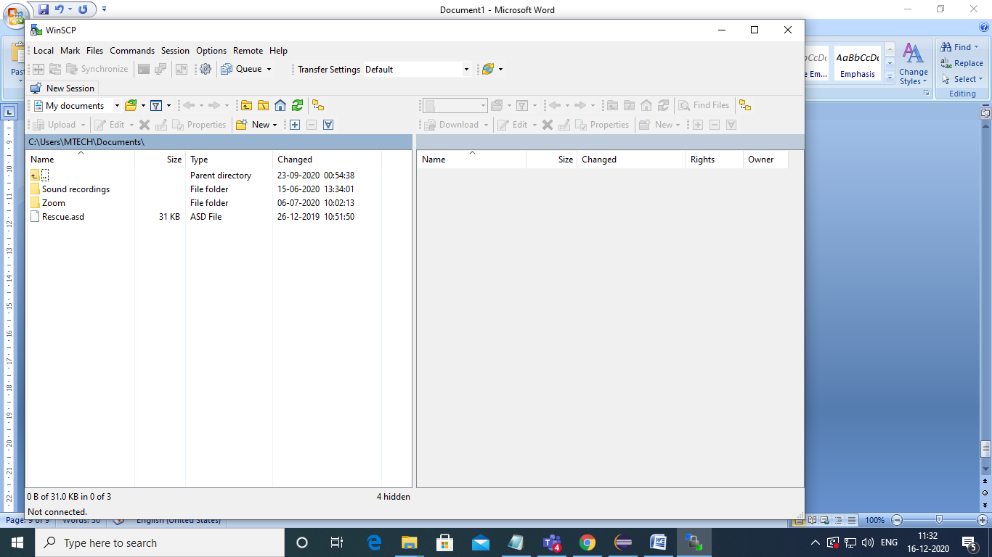

Press newsession

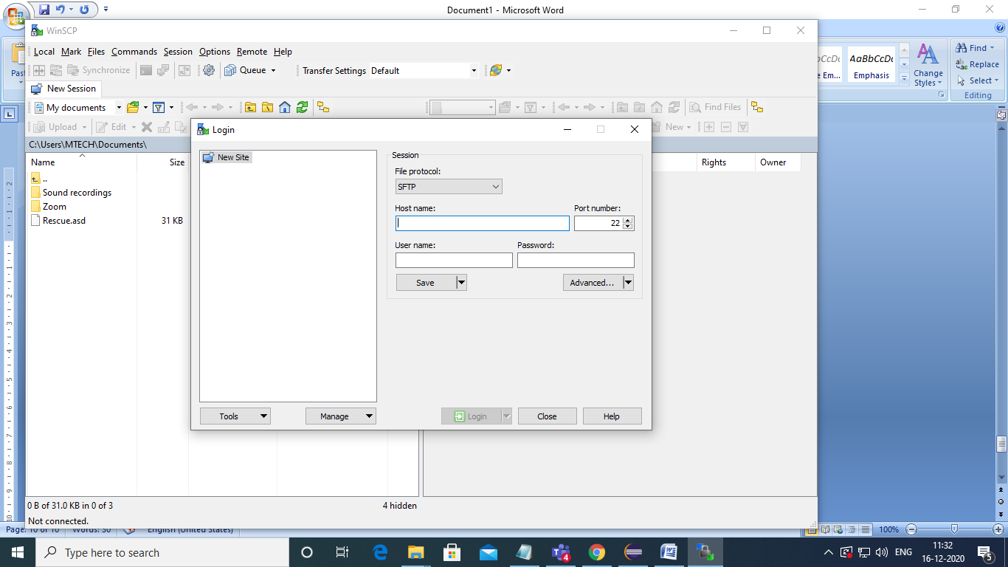

Go to cloudxlab

Change fileprotocol as SFTP

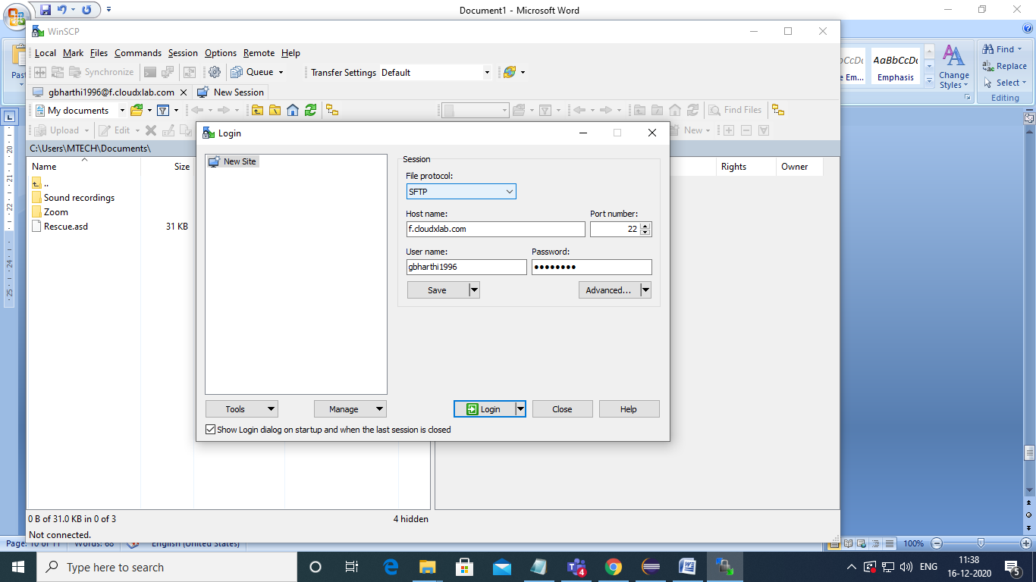

Rightclick webconsole copy linkaddress

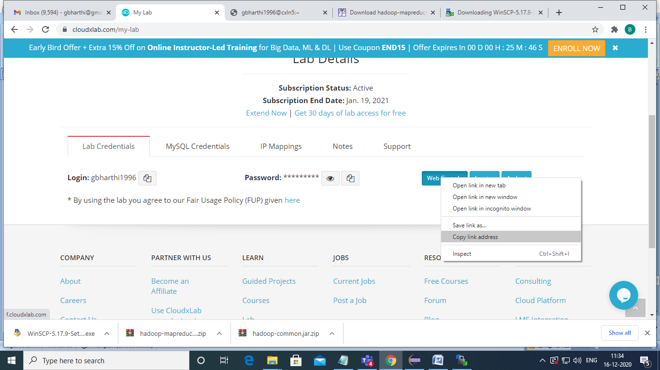

Paste at hostname of winscp

copy username and password of cloudx lab and paste it in winscp to connect to cloudx server to upload jarfile

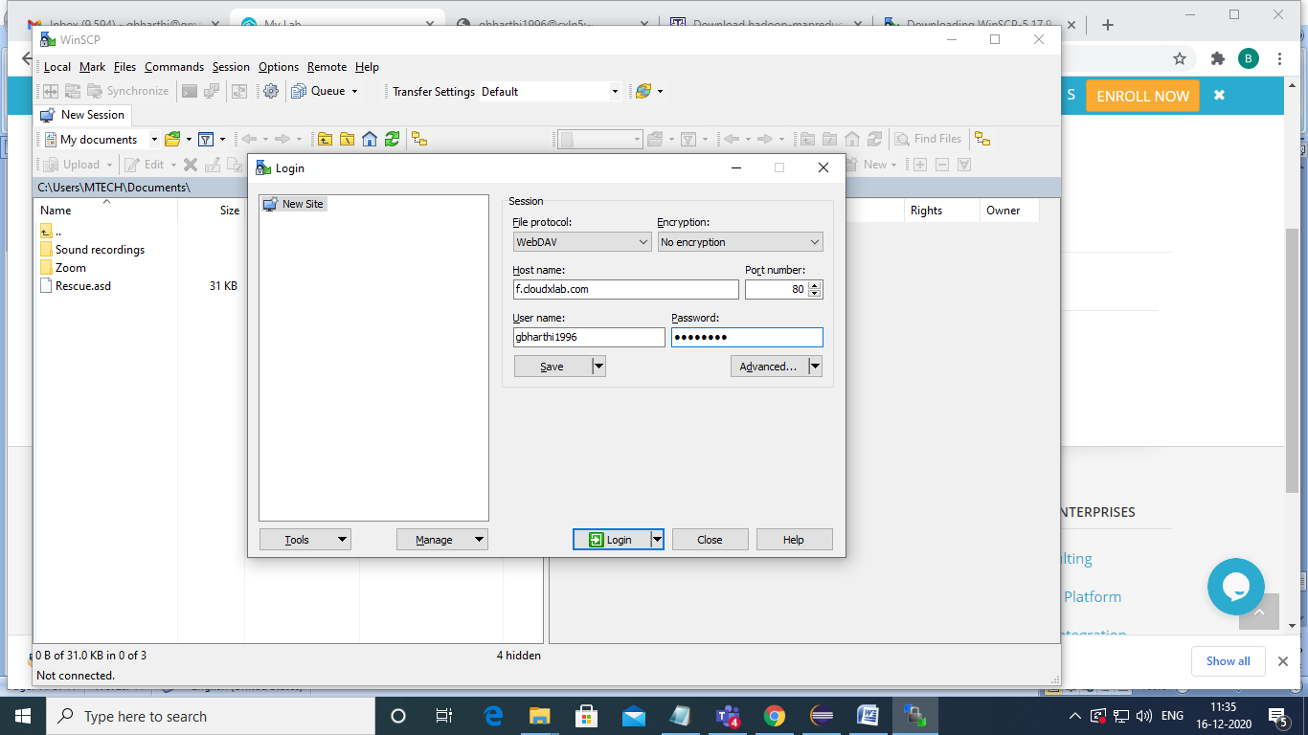

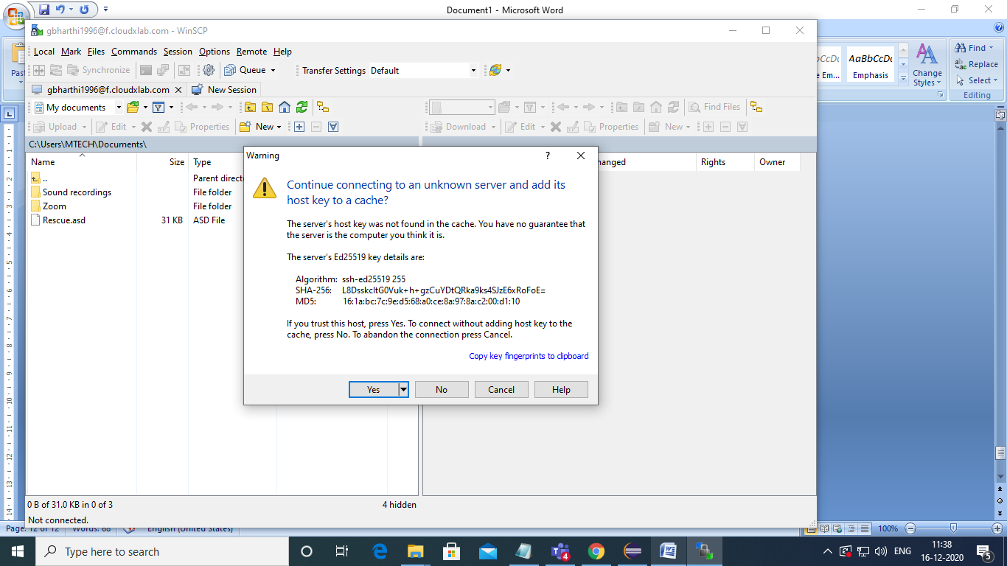

Press yes

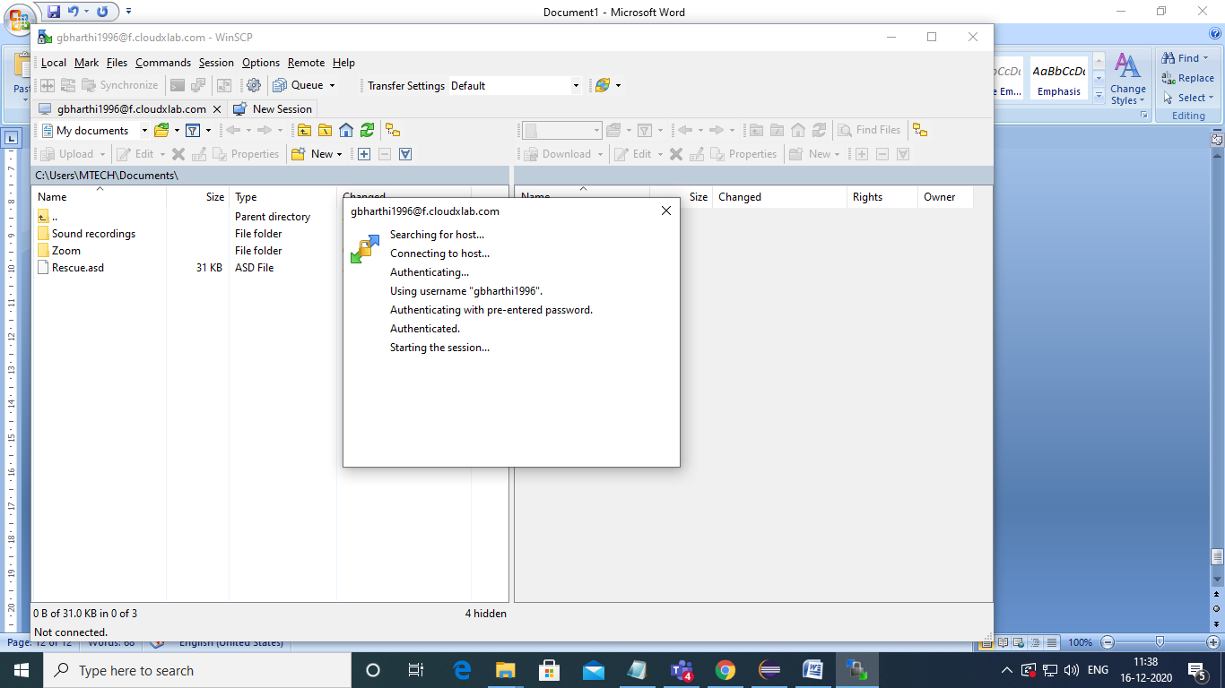

Now connection established.

Then upload jar file and data file

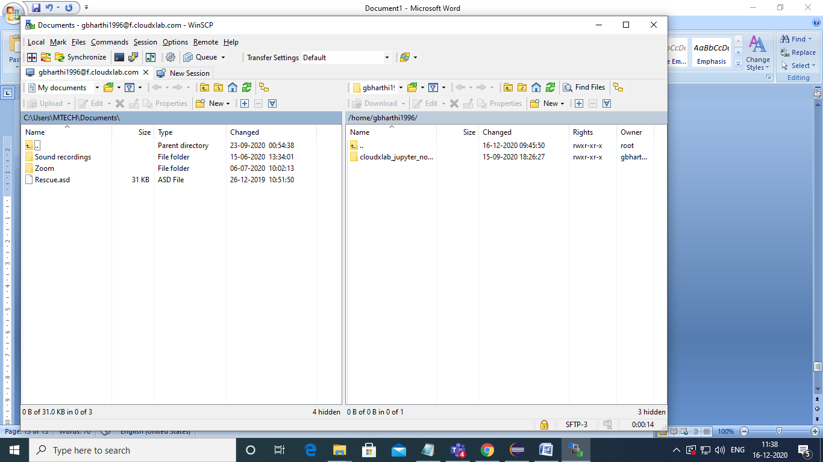

To select jarfile leftside search the file in local disk

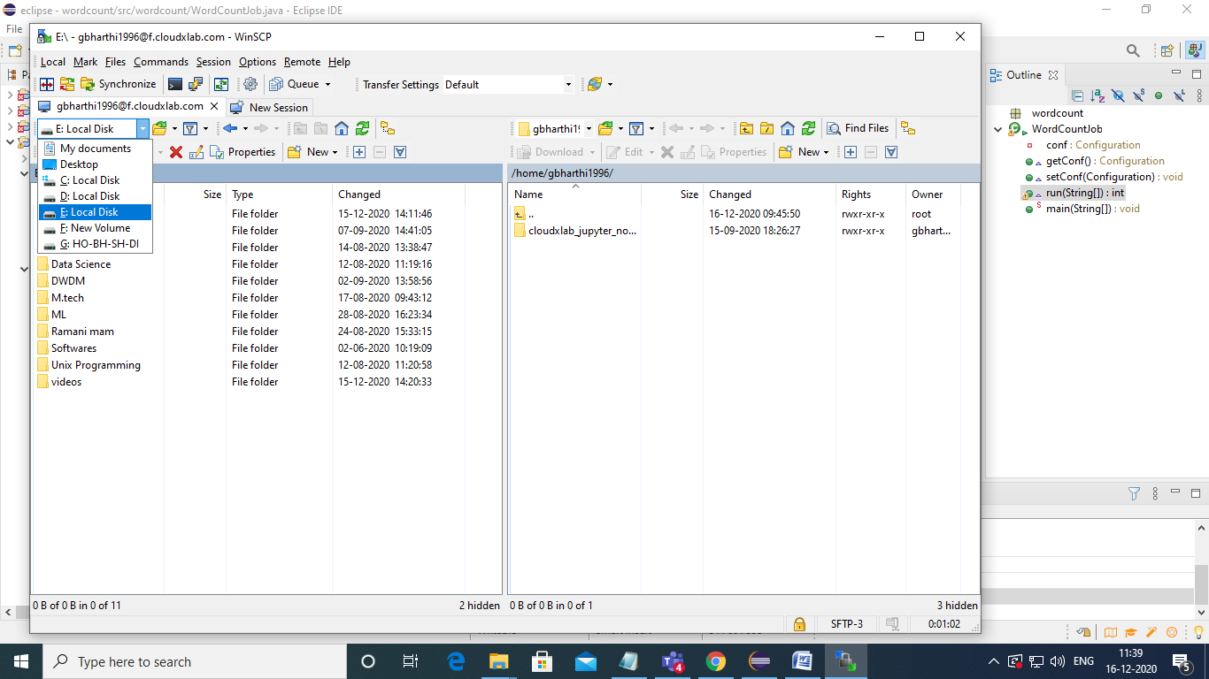

Select jar file then drag and drop

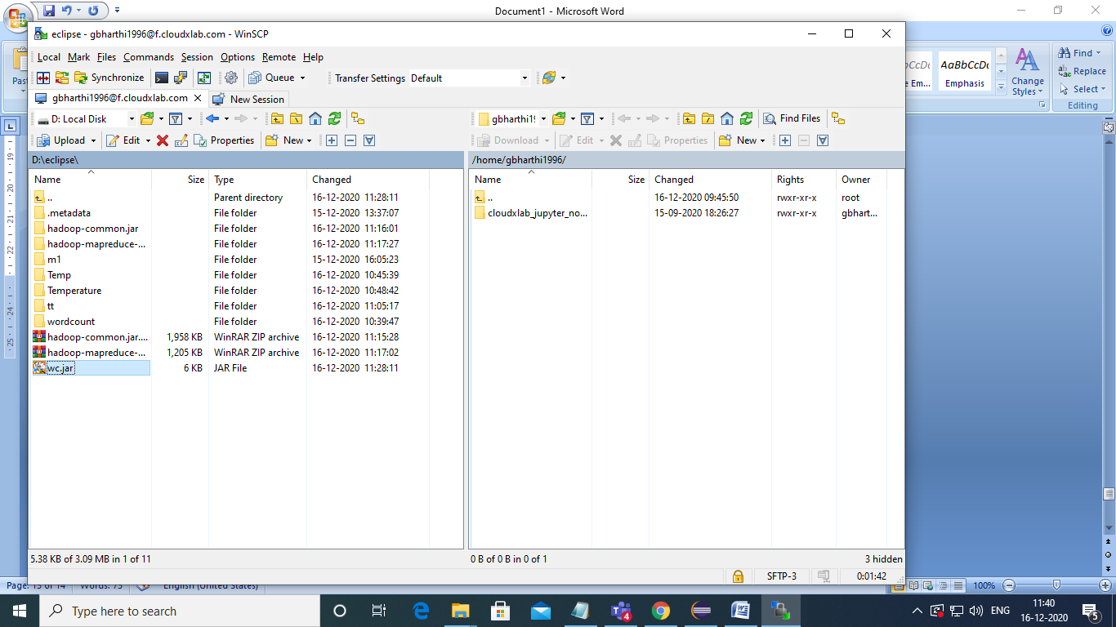

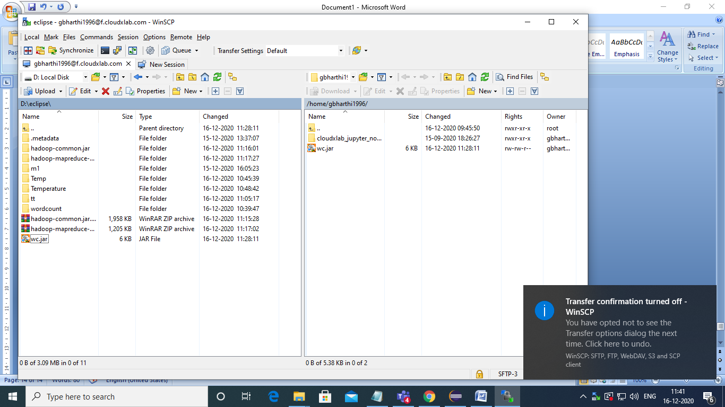

If data file is available that also drag and drop

Here create one text file words.txt

Copy that text file to hadoop by using put command

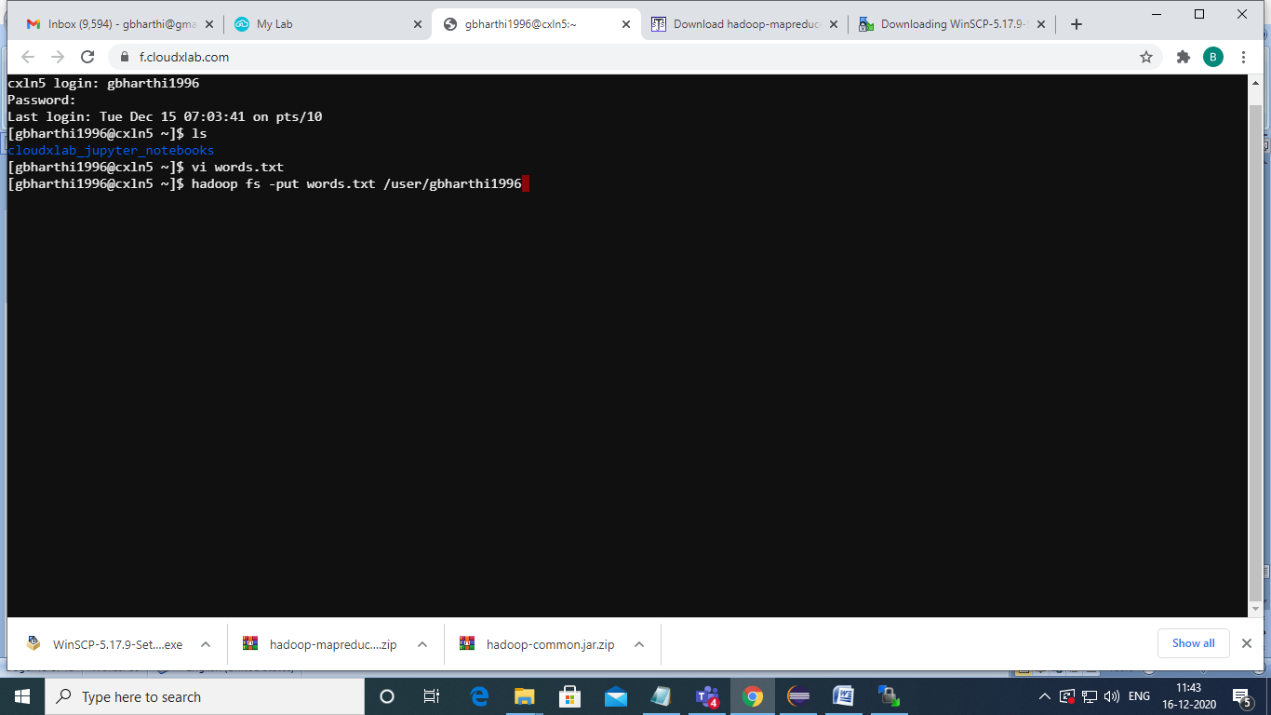

Execute wordcount program

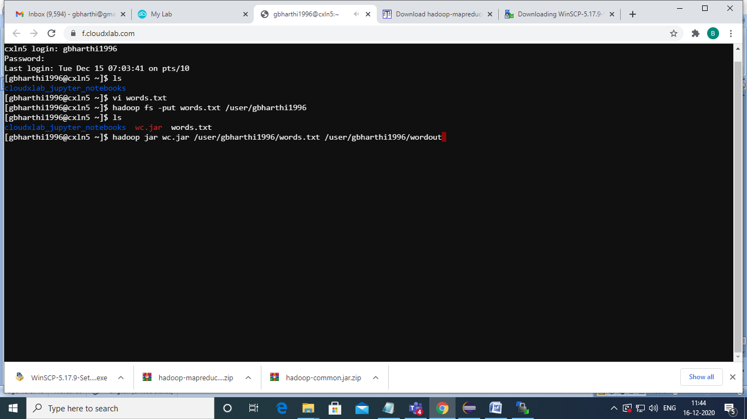

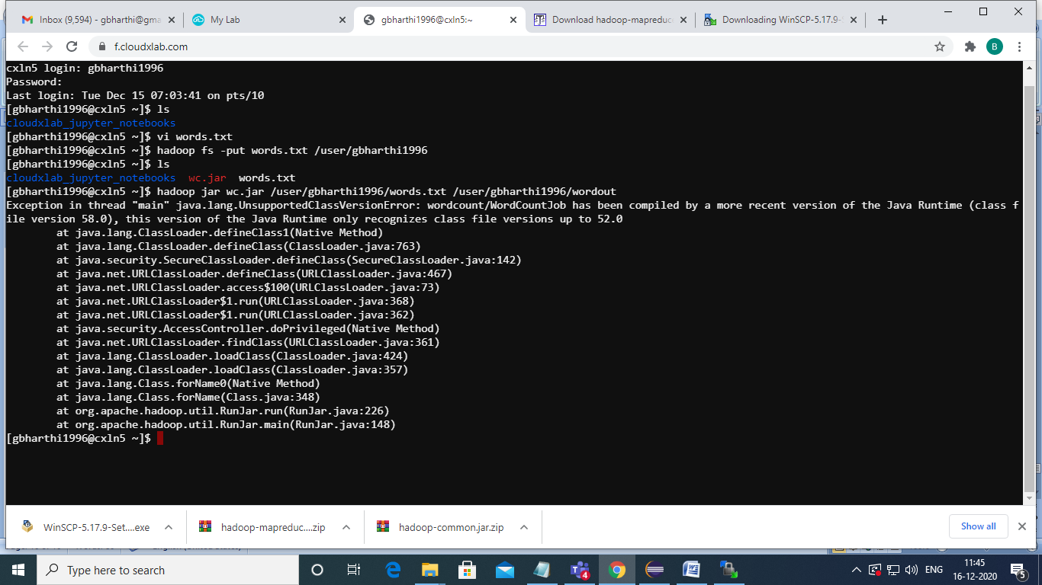

If you get errors change java version in eclipse then again create jar file with java version 1.8

In eclipse select properties

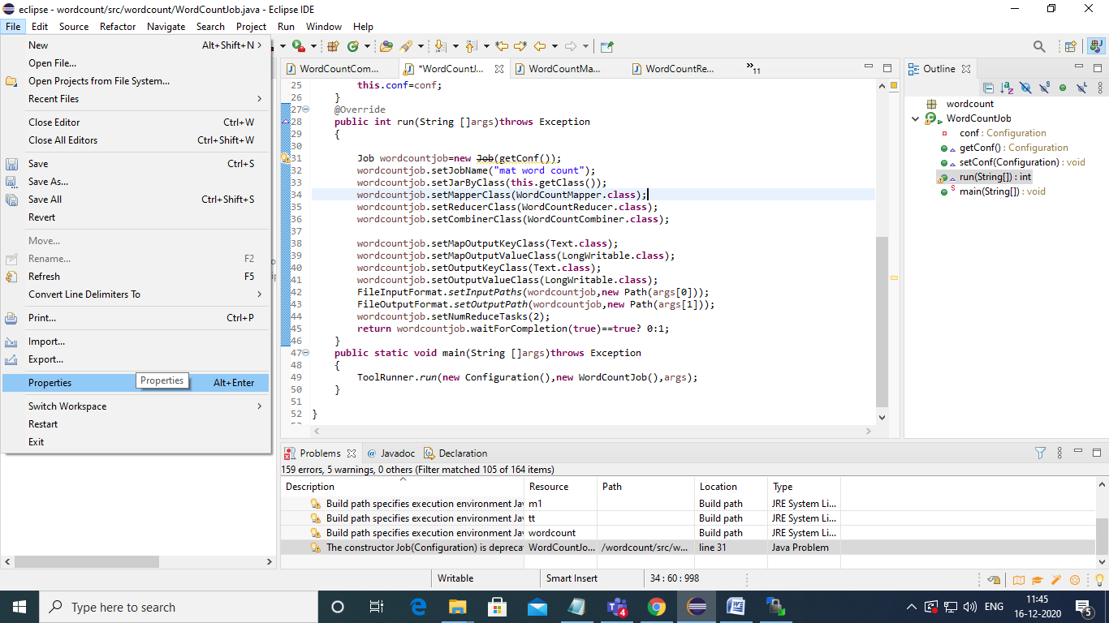

Deselect use compliance from execution envirtonment

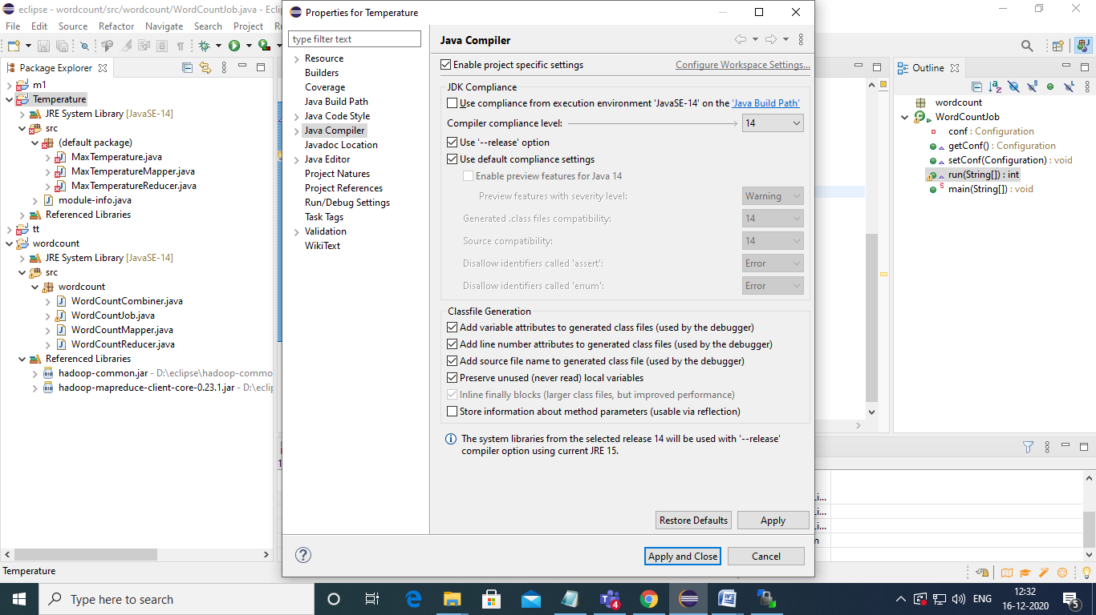

Select 1.8 version instead of 14

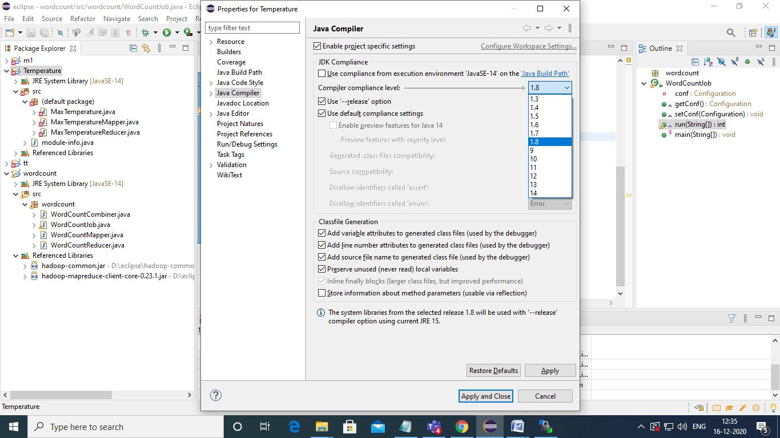

Apply

Then apply and close

Again create jar file then upload that file to cloudx

Then execute

